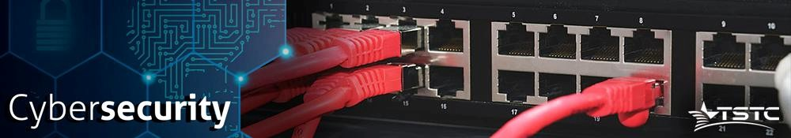

Module 4 Performance Assessment

(Single-Area OSPF)

# Introduction

In this Module 4 Performance Assessment, your focus is OSPFv2 and OSPFv3 for IPv6 configurations.

**Objectives**

Complete all requirements below.

# Assignment

In this Module 4 Performance Assessment your focus is OSPFv2 and OSPFv3 configurations. You will configure IP addressing for all devices. Then you will configure OSPFv2 routing for the IPv4 portion of the network and OSPFv3 routing for the IPv6 portion of the network. One router will be configured with both IPv4 and IPv6 configurations. Finally, you will verify your configurations and test connectivity between end devices.

# Required Resources

If working online:

* Your Computer workstation
* Cisco Packet Tracer (online)
* Provided Packet Tracer File

# Topology

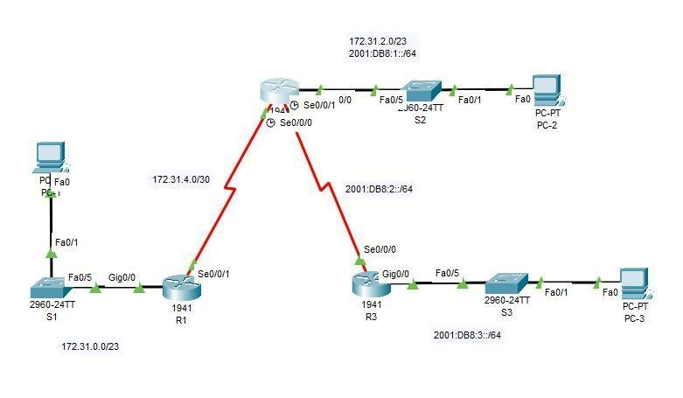

# Addressing Table

|  |  |  |  |  |
| --- | --- | --- | --- | --- |
| **Device** | **Interface** | **IPv4 Address** | **Subnet Mask** | **Default**  **Gateway** |
| **IPv6 Address/Prefix** | |
| R1 | G0/0 | 172.31.0.1 | 255.255.254.0 | N/A |
| S0/0/0 | 172.31.4.1 | 255.255.255.252 | N/A |
| R2 | G0/0 | 172.31.2.1 | 255.255.254.0 | N/A |
| 2001:DB8:1::1/64 | | N/A |
| S0/0/0 | 172.31.4.2 | 255.255.255.252 | N/A |
| S0/0/1 | 2001:DB8:2::1/64 | | N/A |
| R3 | G0/0 | 2001:DB8:3::1/64 | | N/A |
| S0/0/0 | 2001:DB8:2::2/64 | | N/A |
| PC-1 | NIC | 172.31.1.254 | 255.255.254.0 | 172.31.0.1 |
| PC-2 | NIC | 172.31.3.254 | 255.255.254.0 | 172.31.2.1 |
| 2001:DB8:1::2 | | FE80::1 |
| PC-3 | NIC | 2001:DB8:3::2 | | FE80::3 |

# Requirements

* Use the following requirements to configure **R1** addressing and OSPFv2 routing: ○ IPv4 addressing according to the Addressing Table.
  1. Process ID 1

○ Router ID 1.1.1.1

○ Advertise all local IPv4 networks, (Area 0)

○ LAN interface set to passive (do not use the default keyword).

* Use the following requirements to configure **R2** addressing, OSPFv2 routing and OSPFv3 Routing:
  1. IPv4 and IPv6 addressing according to the Addressing Table. ○ Set the Gigabit Ethernet 0/0 Link Local address to FE80::1 ○ OSPFv2 routing requirements:

○ Process ID 1

○ Router ID 2.2.2.2

○ Advertise all local IPv4 networks (Area 0)

○ LAN interface set to passive (do not use the default keyword).

○ OSPFv3 routing requirements:

○ Enable IPv6 routing.

○ Process ID 1

○ Router ID 2.2.2.2

○ Enable OSPFv3 on each local ipv6 interface.

* Use the following requirements to configure **R3** addressing and OSPFv3 routing:
  1. IPv6 addressing according to the Addressing Table ○ Set the Gigabit Ethernet 0/0 Link Local address to FE80::3 ○ OSPFv3 routing requirements:

○ Enable IPv6 routing.

○ Process ID 1

○ Router ID 3.3.3.3

○ Enable OSPFv3 on each local ipv6 interface. (Area 0)

* Configure PCs with appropriate addressing.
  1. PC-1 and PC-2 IPv4 addressing must use the last assignable address in the IPv4 subnet.

○ PC-2 and PC-3 IPv6 addressing must use the second assignable address in the IPv6 network and the link-local FE80 address as the default gateway. ○ Finish the Addressing Table documentation.

* Verify your configurations and test connectivity
  1. OSPF neighbors should be established and routing tables should be complete.

○ Pings between PC-1 and PC-2 should be successful.

○ Pings between PC-2 and PC-3 should be successful.

**Note:** If OSPFv3 has not converged, check the status of interfaces using the show ip ospf interface command. Sometimes, the OSPFv3 process needs to be deleted from the configuration and reapplied to force convergence.

**Submit Your Work:**

Packet Tracer:

Submit Packet Tracer file as well as your text file with your findings and notes.

Physical Lab:

Submit the running configuration(s) for each device used, along with the items requested to record to the instructor for grading.

# Rubric

Checklist/Single Point Mastery

|  |  |  |
| --- | --- | --- |
| Concerns  Working Towards Proficiency | Criteria  Standards for This Competency | Accomplished  Evidence of Mastering Competency |
|  | Criteria #1: Set Up Network (31 Points) | Basic IP configs. (31 pts)  3 routers each (10.3 pts) |
|  | Criteria #2: Routing (49 pts) | OSPF v2 and v3 configs for IPv4 and IPv6 (49 pts)  R1 and R2 - OSPFv2 config each (12.25 pts)  R2 and R3 - OSPFv3 config each (12.25 pts) |

|  |  |  |
| --- | --- | --- |
|  | Criteria #3: Troubleshooting and Verification (20 Pts) | All 4 connectivity test work. (20 pts)  Pings  PC-1 to PC-2. (5 pts)  PC-3 to PC-2. (5 pts)  Router 1 to Router 2, (5 pts)  Router 3 to Router 2. (5 pts) |